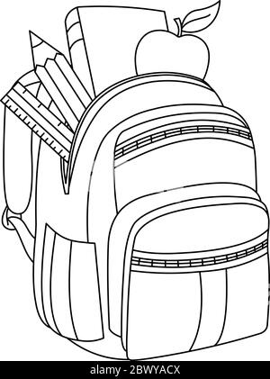

Individual pencil sharpeners

Rulers

8” Scissors

Mechanical pencils

Highlighters

Post it notes 3” x 3”

Index cards

Large eraser

Notebook filler paper

Supplies needed:

Headphones

Duotang folders

Glue sticks

Markers

Composition notebooks

Spiral notebooks

Fine tip black sharpies

Black sharpies

1” 3-ring binder

**Help Support Local Students!**